**Biography**

**Developer Guide**

|  |  |  |
| --- | --- | --- |
| **Supervisor:** | Sir Muhammad Ikram |  |
| **Batch:** | 2309E3 |  |
| **Group:** | C |  |
| **Serial no.** | **Enrollment number** | **Student Name** |
| 1. | *Student1511010* | Shakir Muhammad |
| 2. | *Student1510202* | Muzammil Shafiq |
| 3’. | *Student1512095* | Ahmad |
| 4 | *Student1509187* | Shayan |



**Home (Index.html)**

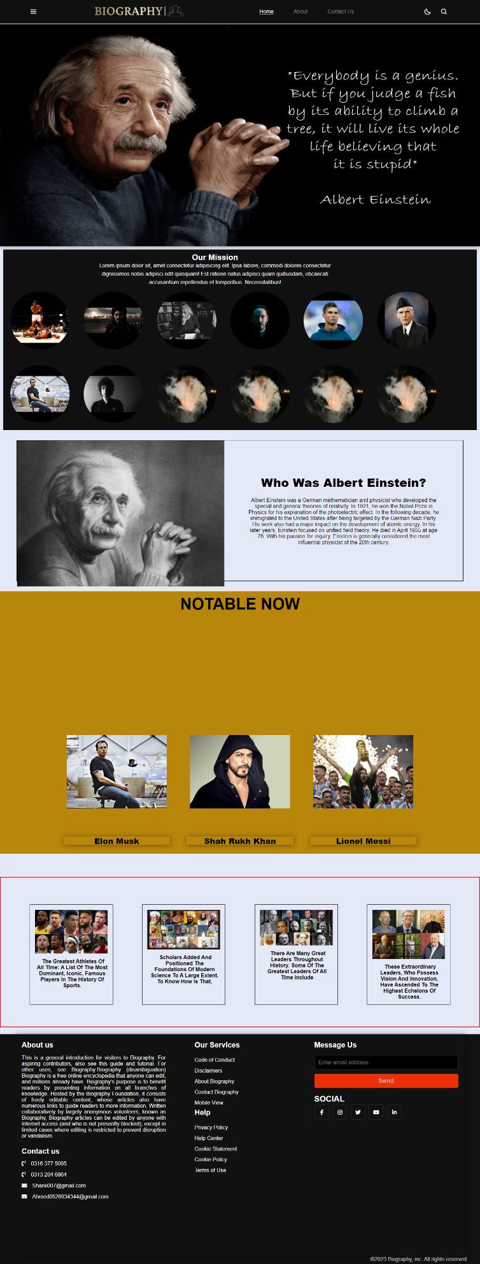

Figure 1: Home Page For Our Biography Website:

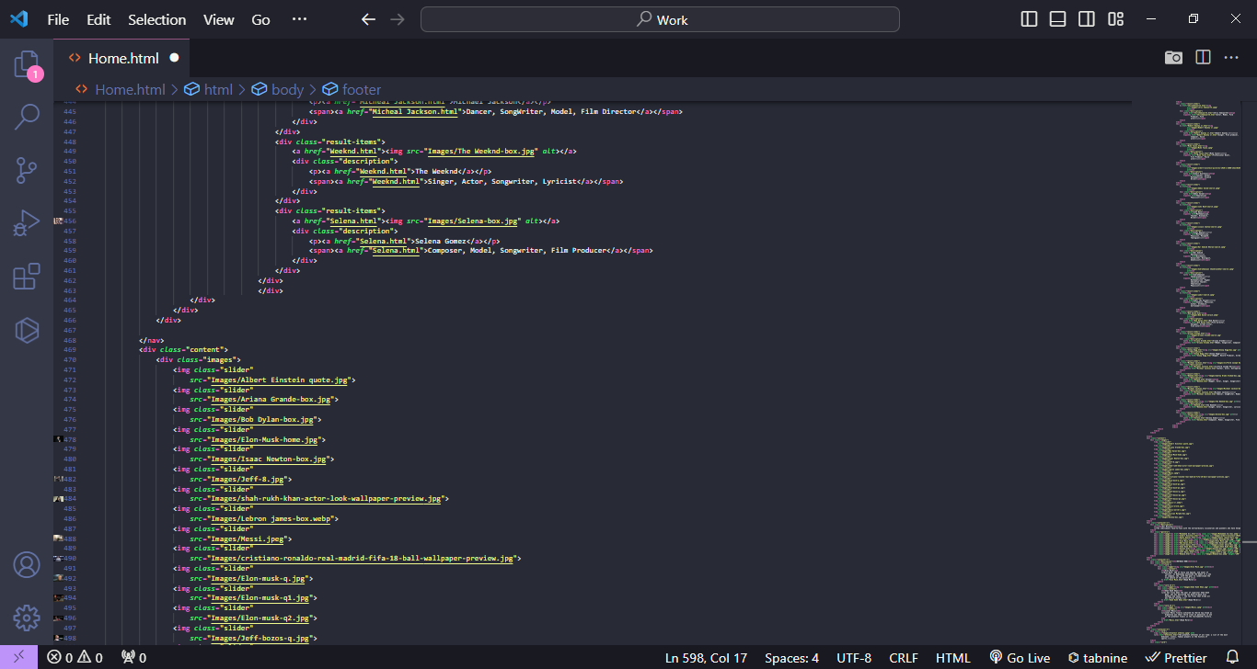

Code Of Home Page:

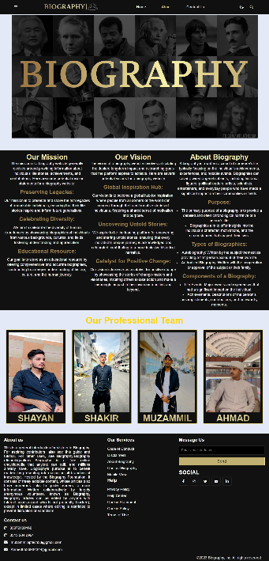

**About page**

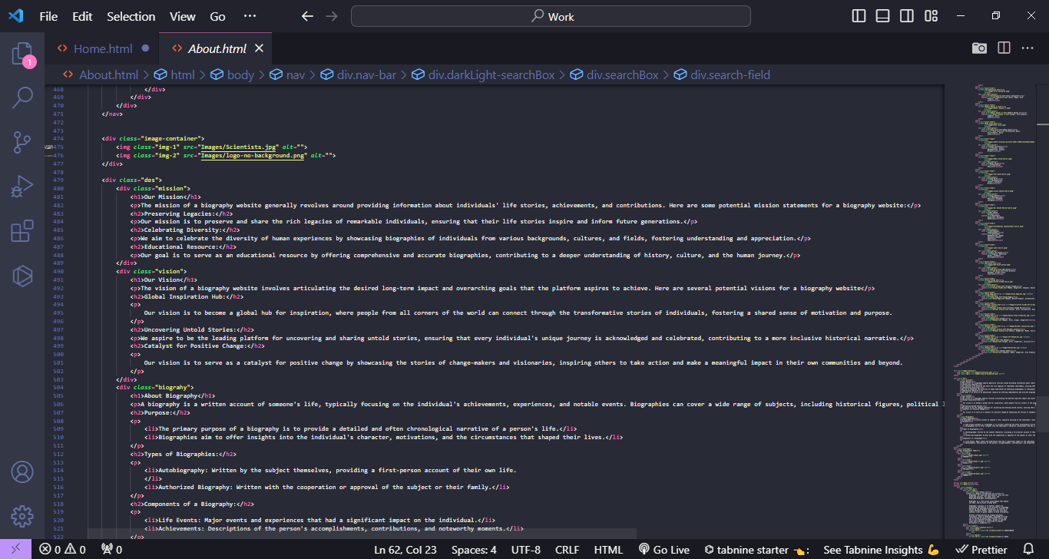

**Code of About Page**

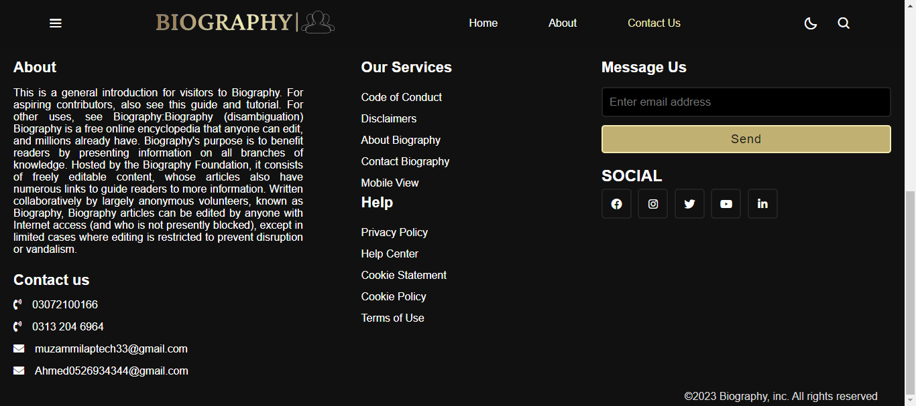

**Footer Code**

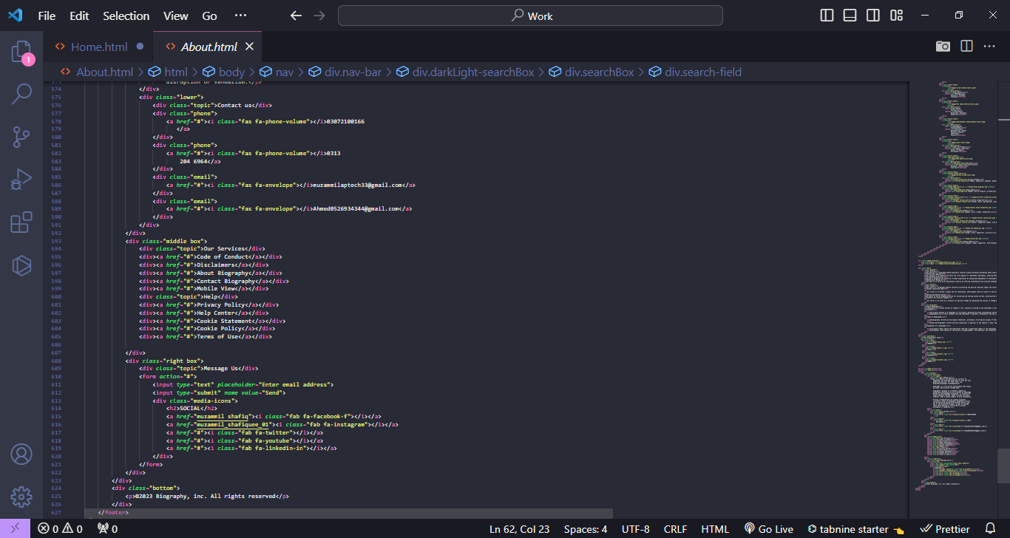

**Navbar**



**Navbar Code:**

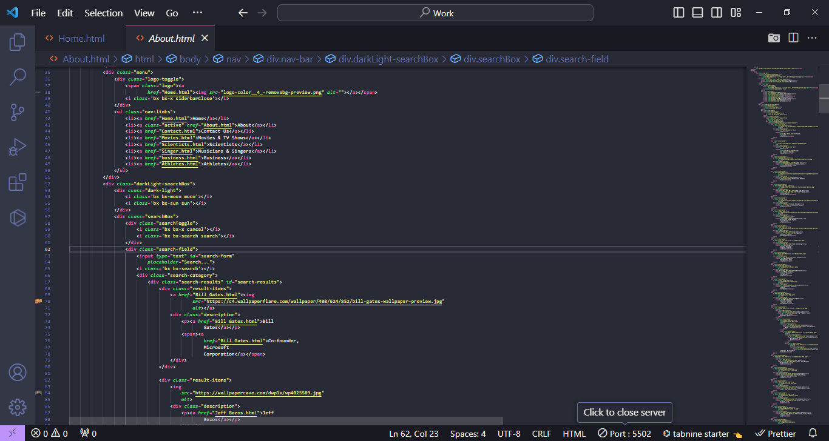

**Athletes**

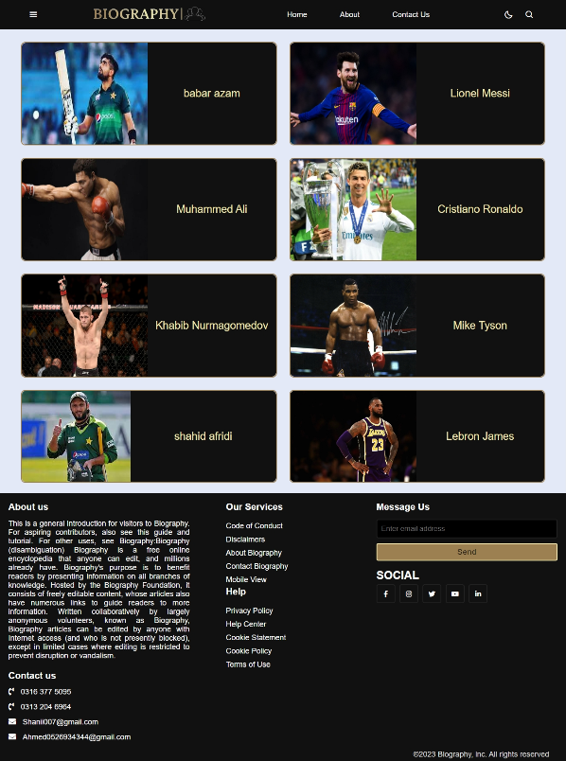

**Athletes Code**

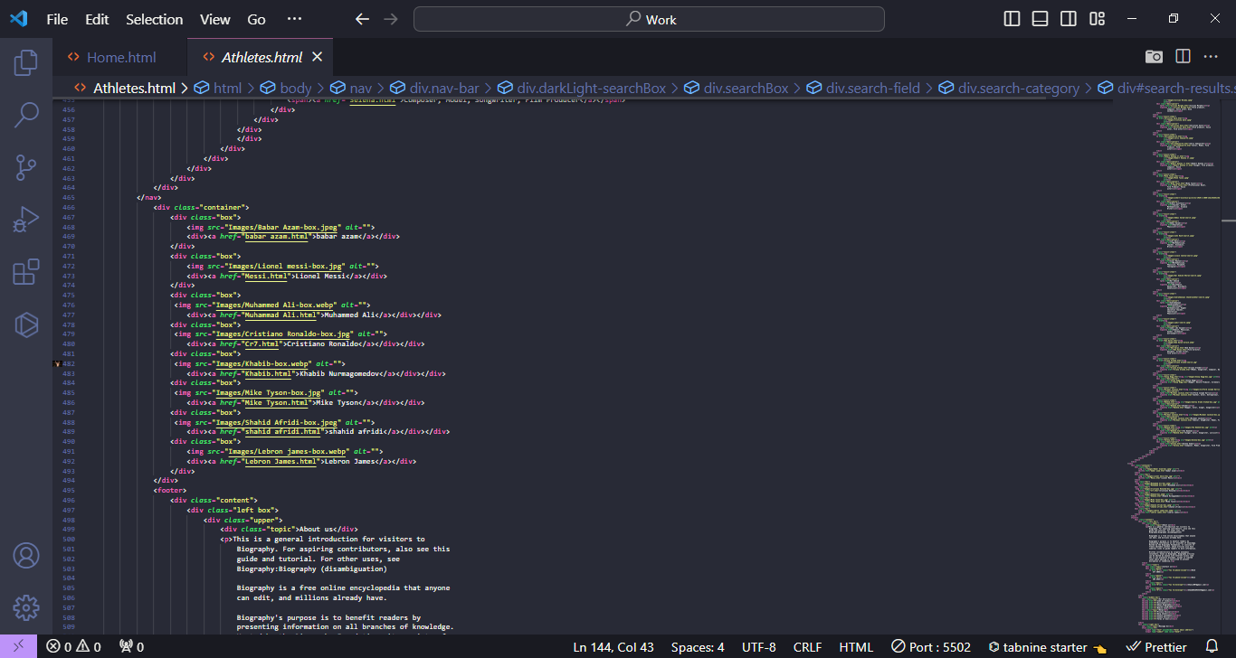

**Contact Us page**

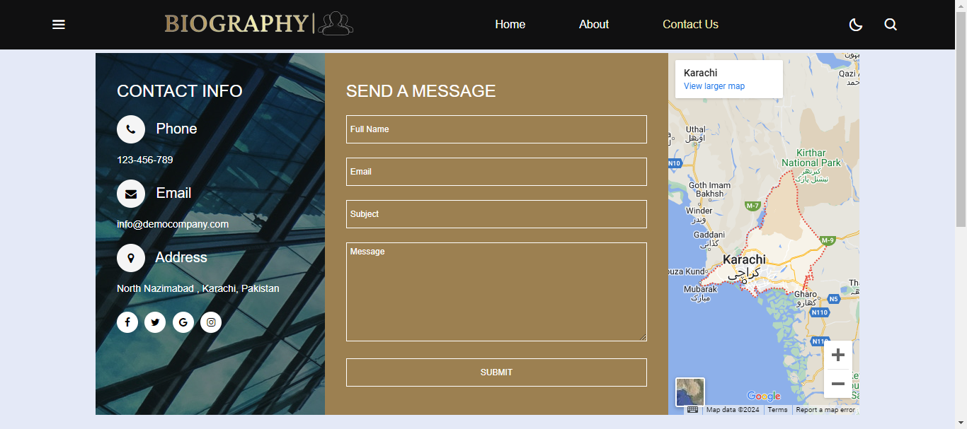

**Contact Us page**

